Image result for diode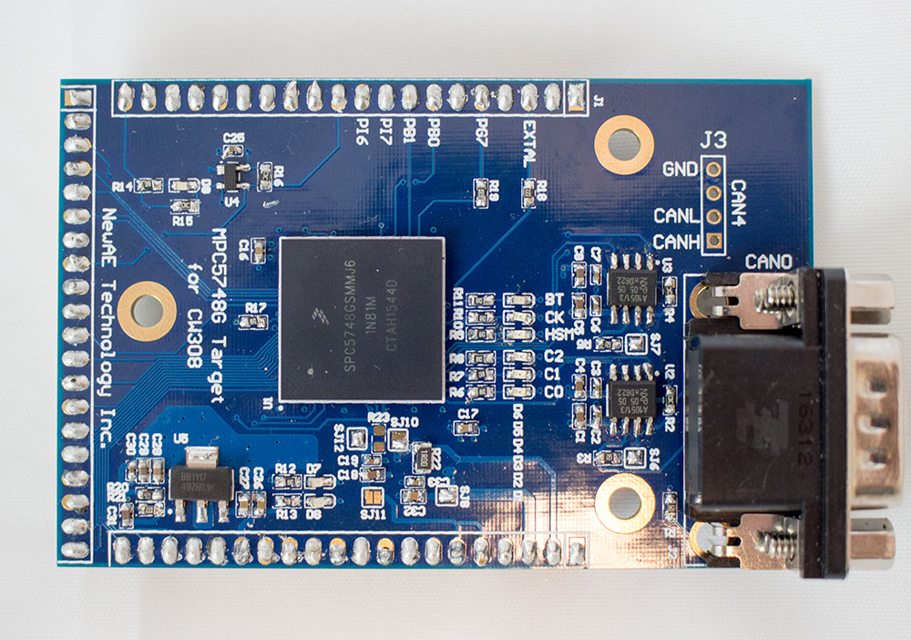

LED Polarity (all LEDs on PCB)

Solder Jumpers set by stencil

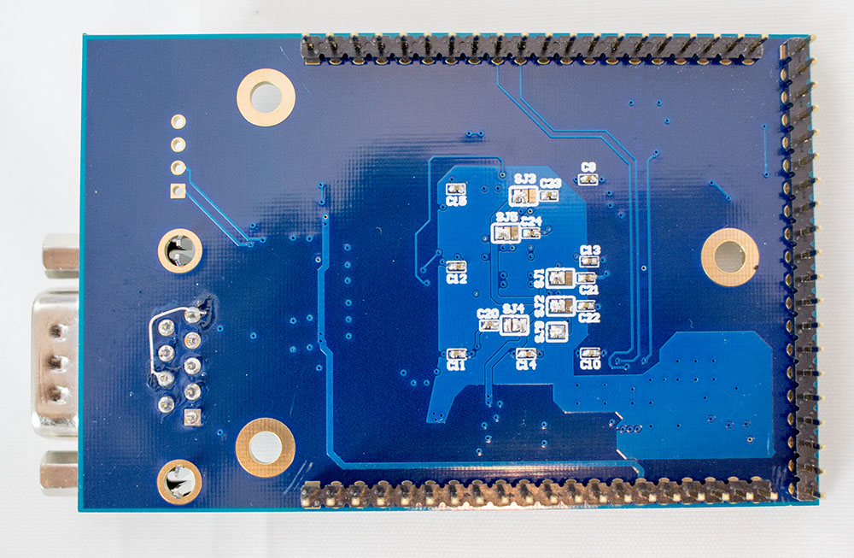

**NOTES**

* J1 consists of 3x 20-pin headers mounted on underside of PCB. Headers mount into mating sockets, so must be vertical.
* Various solder jumpers on PCB are set by the provided stencil file (solder paste will short SJ that should be shorted).
* Two additional 4-pin headers not shown are mounted from top side.
* The ‘fix’ on DB9 connector (J2) is not required -02 build.
* U1 has two possible part numbers depending on variant.